**Designing a logo with Canva**

**Introduction:**

Designing a logo is all about capturing the essence of your brand and making a lasting impression. Canva provides you with the tools to easily create a professional and eye-catching logo, so don't be afraid to experiment and let your creativity shine!

**Problem and Design thinking:**

**EMPATHY MAP**

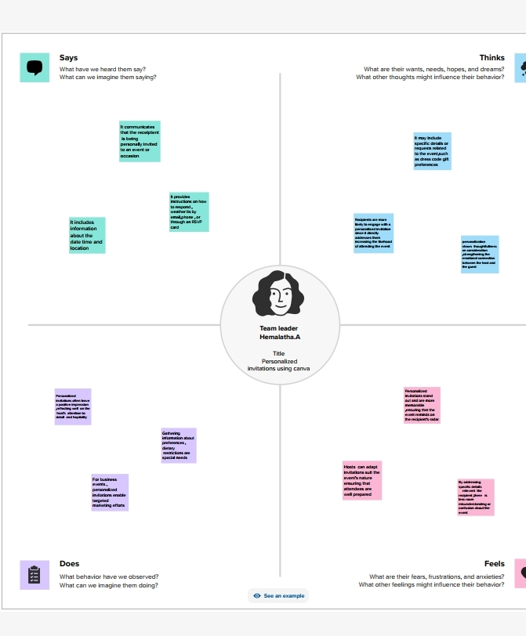

**BRAINSTORMING MAP**

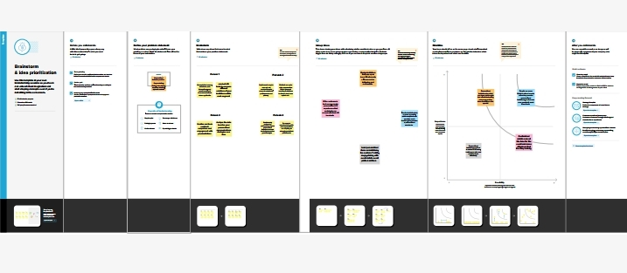

**Result:**

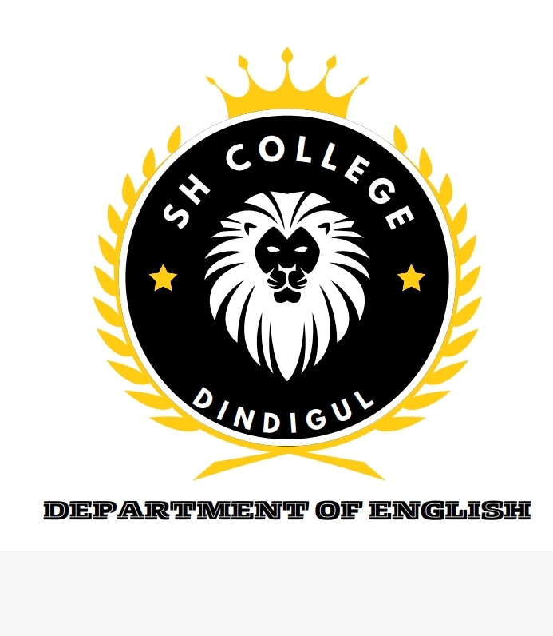

**Advantages and disadvantage:**

Advantages:

**Brand Identity**: A well-designed logo can help establish a strong brand identity, making your business more recognizable and memorable to customers.

Disadvantages:

**Time and Effort**: Designing a logo can be a time-consuming process, especially if you're starting from scratch and have no design experience.

**Applications**:

There are several applications available that you can use for designing a logo. Here are a few popular ones:

**Canva:** Canva offers a user-friendly interface with a wide range of templates, fonts, and graphics to create a logo. It also provides customization options and the ability to export your logo in various formats.

**Conclusion:**

Conceptualization: Generate ideas and concepts based on the research. This involves brainstorming, sketching, and exploring different visual elements that represent the brand effectively.